40.1: a) 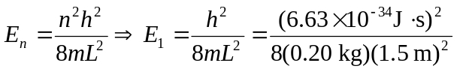
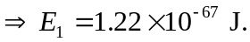
b) 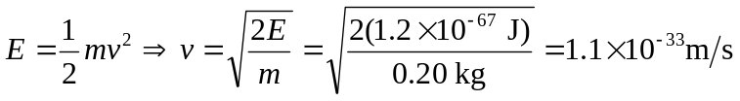
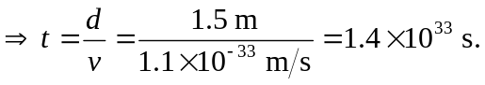
c) 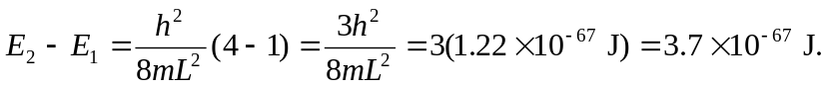
d) No. The spacing between energy levels is so small that the energy appears continuous and the balls particle-like (as opposed to wave-like).

